Launch one EC2 instance using Amazon Linux
1)Install Docker.
We have to create new instance and pem name is bharu that ssh key is connect to the gitbash account start the process…
Come to root usersudo su
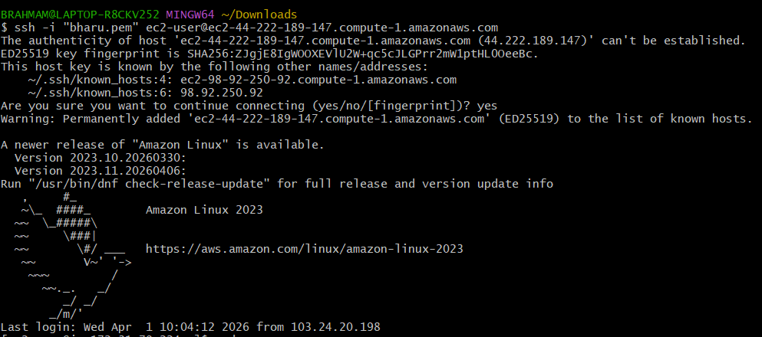
- sudo yum update -y
- yum install docker -y
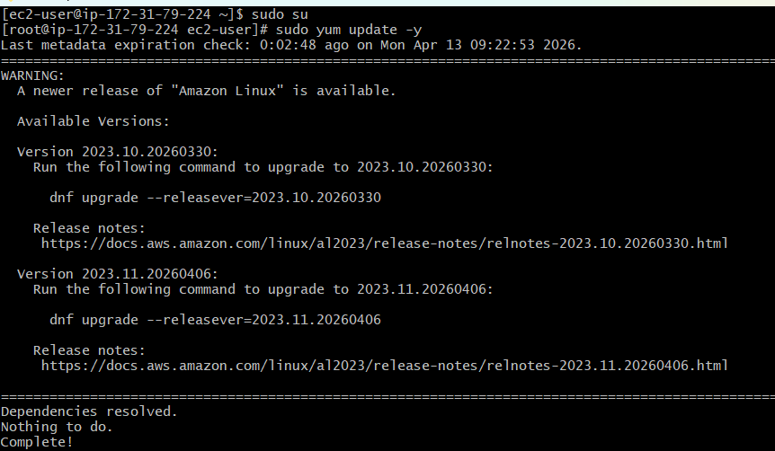
- Systemctl start docker
- Systemctl enable docker
- Systemctl status docker
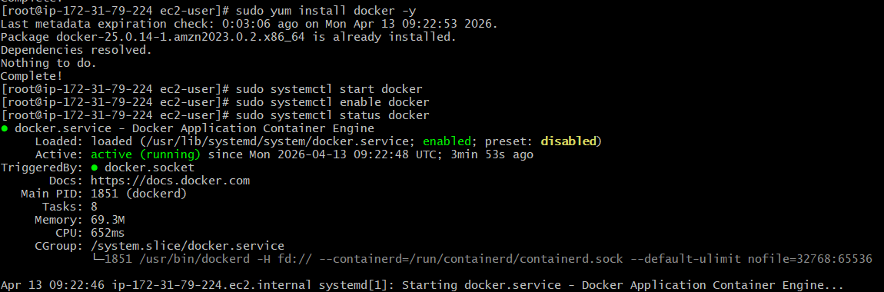
Install Jenkins.
- Sudo yum install java-17-amazon-corretto
- Java -version
- sudo systemctl start jenkins
- sudo systemctl enable jenkins
- sudo systemctl status jenkins

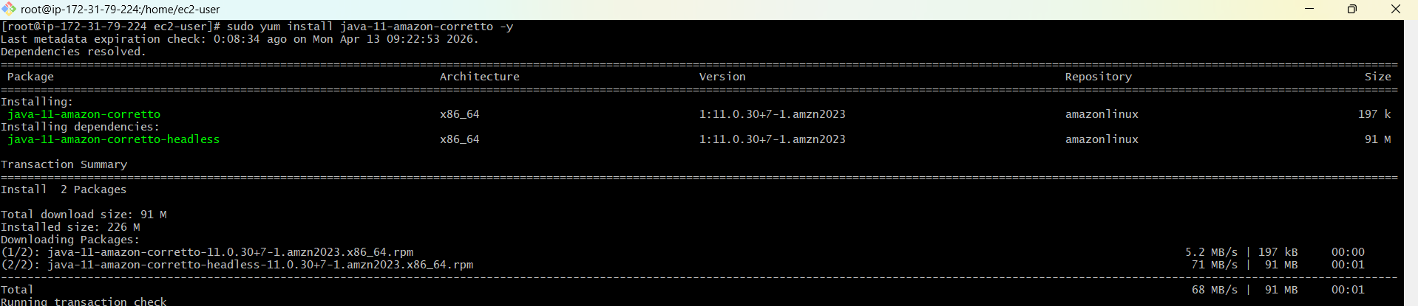
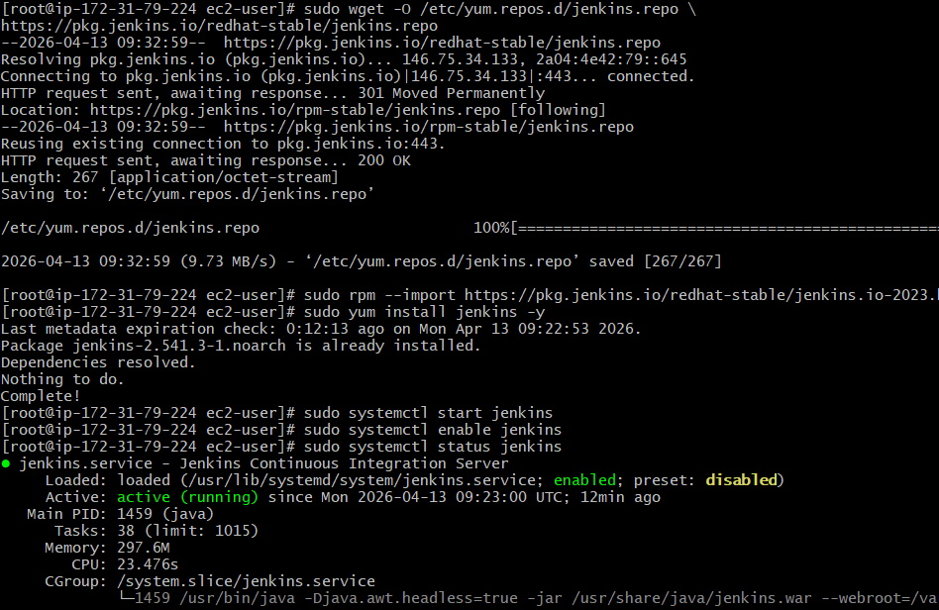
running the port number:8080
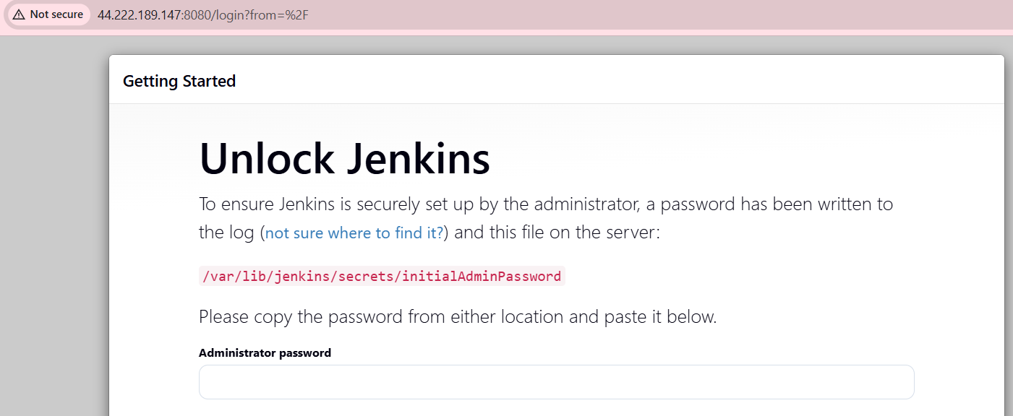
Install Apache. (httpd)
- yum install httpd -y
- sudo systemctl start httpd
- sudo systemctl enable httpd
- sudo systemctl status httpd

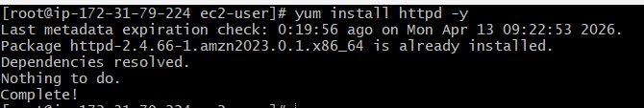
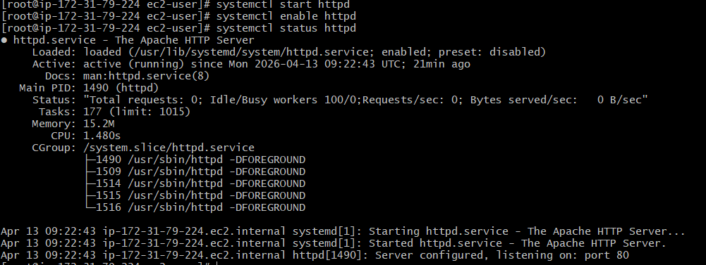
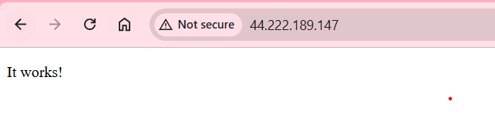

Install Nginx.
- yum install nginx -y
- sudo systemctl start nginx
- sudo systemctl enable nginx
- sudo systemctl status nginx
- /etc/nginx/nginx.conf
- Cd /etc/nginx/ ls sudo systemctl restart nginx
- sudo systemctl enable nginx
- sudo systemctl status nginx
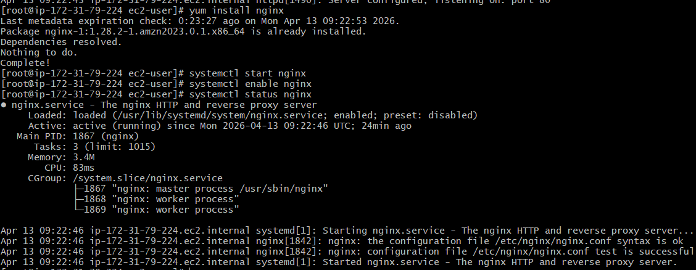
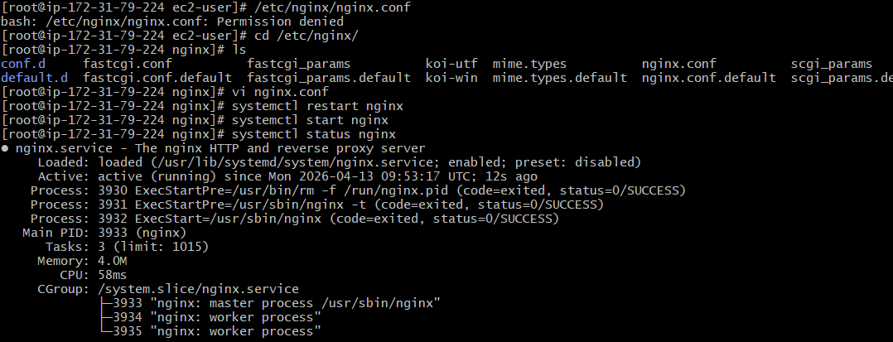
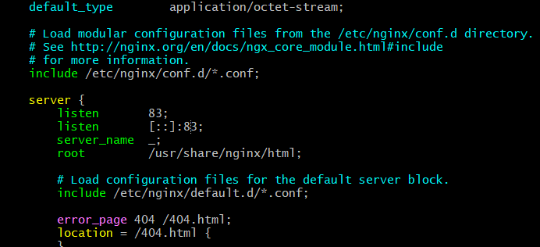
I changed the port number to 83 now its running in 83 port number check below….
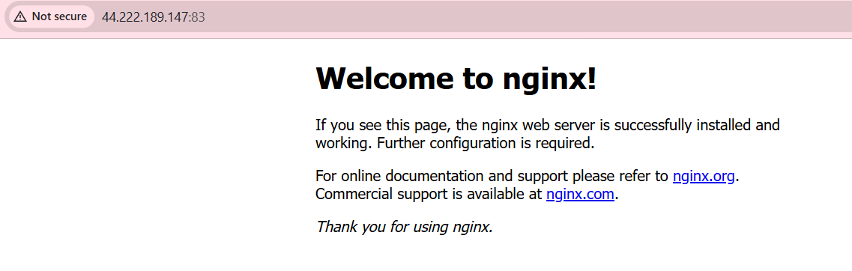

- Install Apache Tomcat.
java-11-amazon-corretto -y
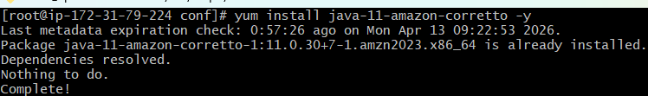
wget https://dlcdn.apache.org/tomcat/tomcat-9/v9.0.117/bin/apache-tomcat-9.0.117.tar.gz using this link -->I download apache tomcat version
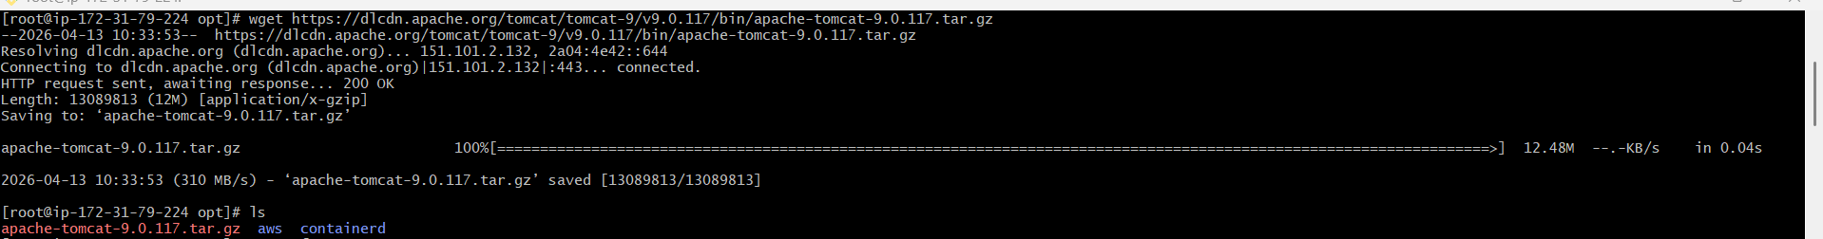
Now I am extract tomcat tar xvf by using this command
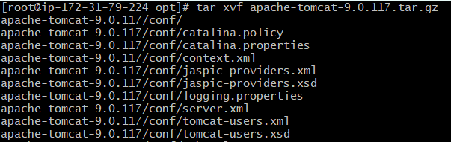
By giving ls --I get list apache tomcat
Now I changed name to tomcat cd tomcat
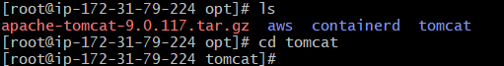
cd bin/lssh startup.shtomcat started
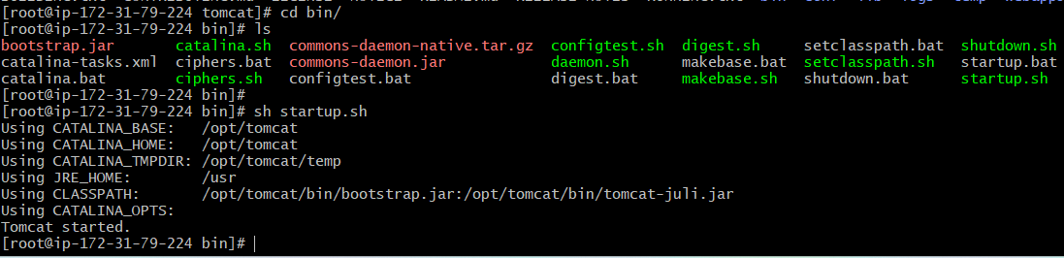
now I am started to change THE PORT number to 8083
